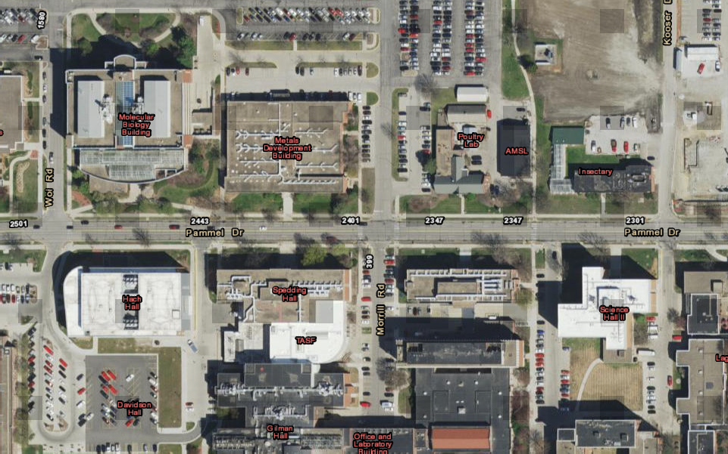

Ames Laboratory Main Campus Evacuation Assembly Points (Orange Pins)

